Running MEDrefer Manager over Remote Desktop Connection
If you run a Remote Desktop Connection, before you install MEDrefer Manager you will need to complete the steps below:

- Open your Control Panel (usually found in your Start Menu)
- Click on Network and Internet link
- Click on Internet Options link
- A pop-up titled Internet Properties will appear
- Select the Advanced tab
- Scroll down to Security and de-select (ensure there is no tick in the box) Do not save encrypted pages to disk
- Click on Apply
- Click on Ok.
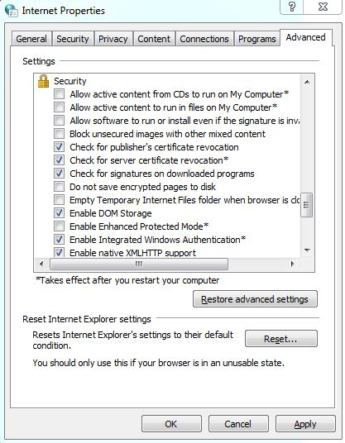

MEDrefer Manager will now be able to download to each GPs desktop.
N.B. - If multiple GPs are using the same desktop, MEDrefer Manager will need to be installed once for each GP while the desktop is logged in under their profile.
For example – Dr Guthrie and Dr Heinrich use the same office for their consults and therefore the same desktop computer. MEDrefer Manager will need to be downloaded when Dr Guthrie is signed into the desktop and again when Dr Heinrich is signed into the desktop.

